Lab No. 12
Part I - Lab Tasks:
- Step 1 to 3: Import Libraries, Acquire Dataset, & Identify Variables
We will import standard data science tools alongside scikit-learn decision tree modules.
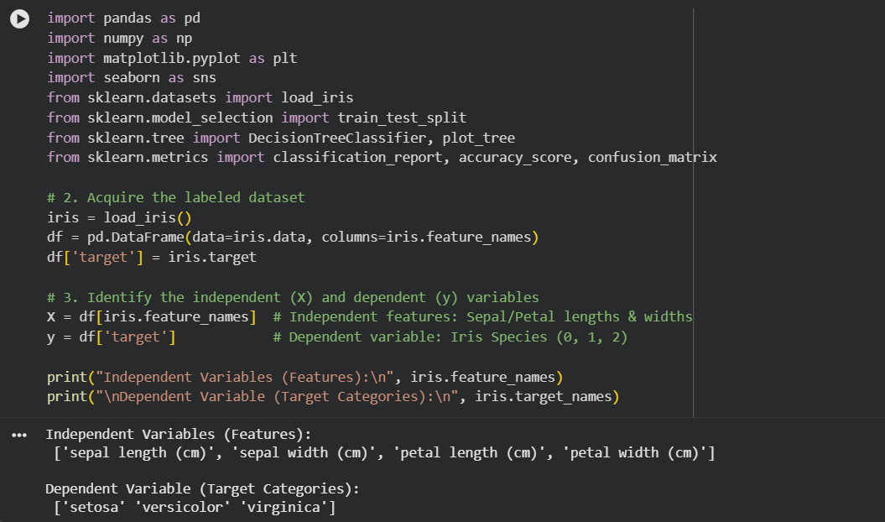

Step 4 & 5: Feature Discussion & Exploratory Data Analysis (EDA)
Understanding distribution profiles helps clarify how a Decision Tree can segment features.
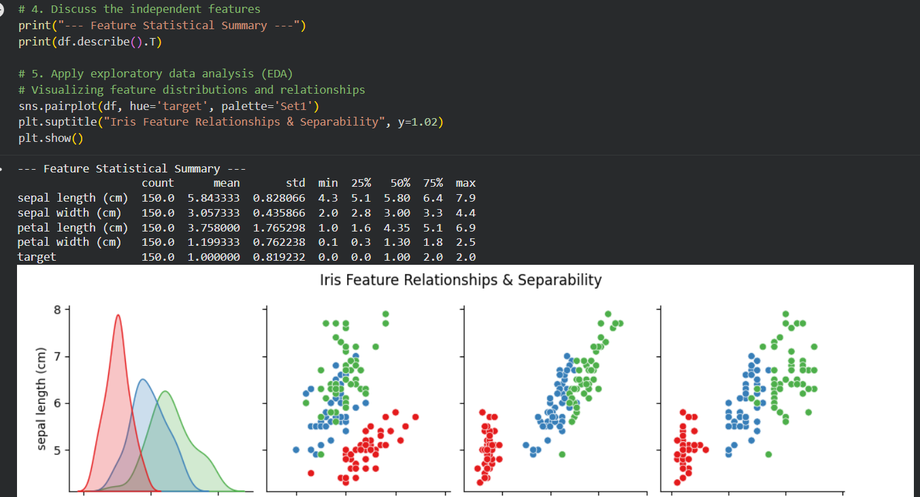
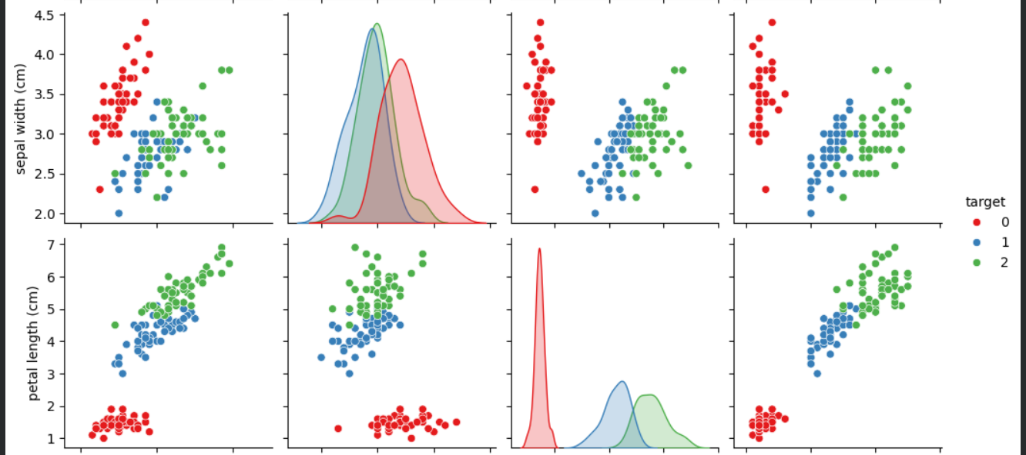
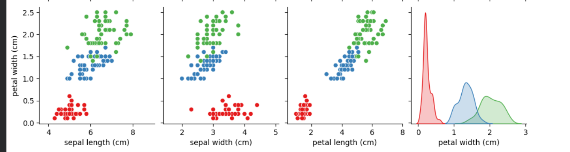

Step 6 & 7: Build and Assess Baseline DT Classification Model
We partition our data using a top-down approach, fit our classifier, and assess its accuracy metrics.
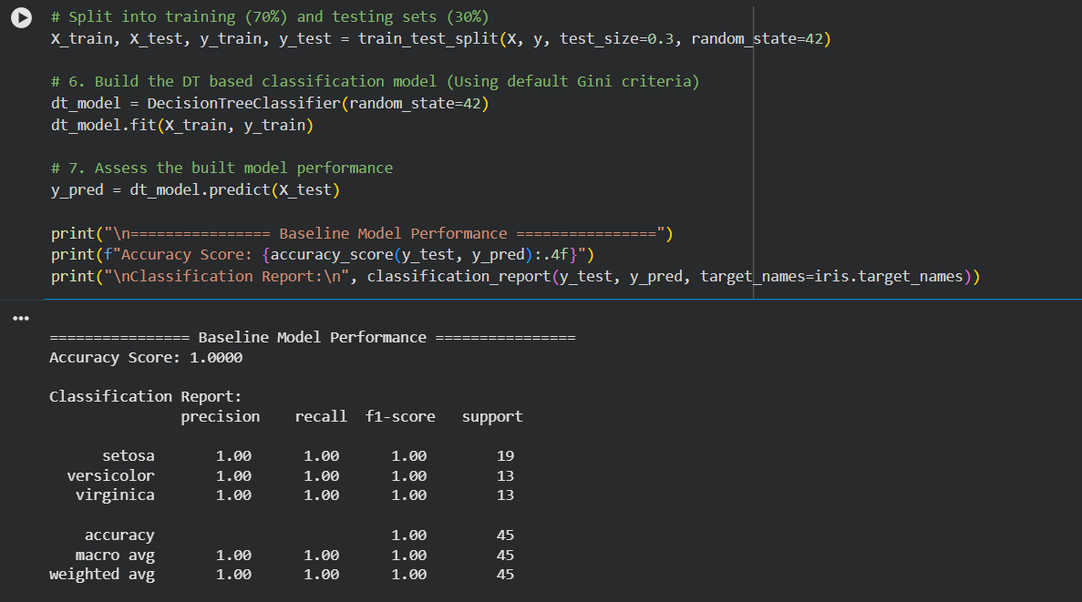

Step 8: Hyperparameter Tuning (Optimizing Internal Parameters)
To prevent overfitting and control the tree's complexity, we explore hyperparameters like max_depth and criterion.
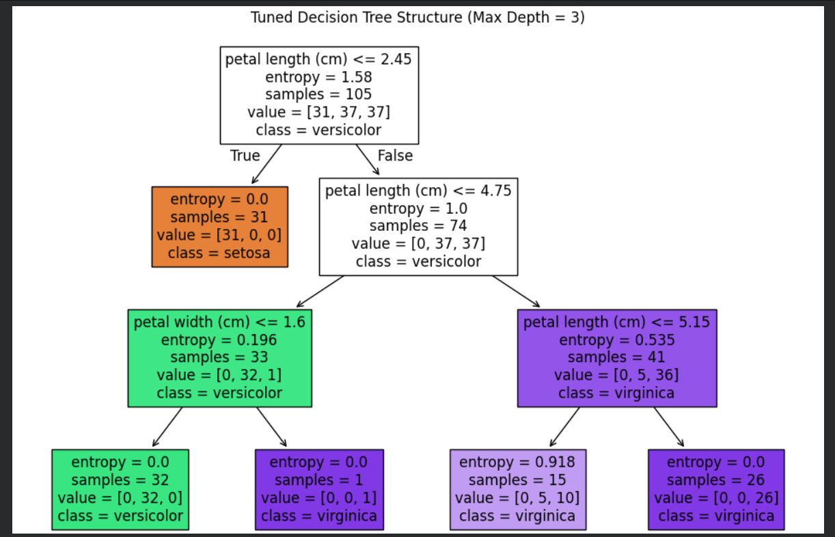

Part II - Assignment Tasks Solutions

Parametric vs. Non-Parametric Machine Learning Algorithms
- Parametric Algorithms: Assume a fixed mathematical functional form for the underlying mapping data distribution (e.g., Linear Regression, Logistic Regression). They require fewer data points but are less flexible.
- Non-Parametric Algorithms: Do not make explicit structural assumptions about the shape of the underlying mapping function. They grow flexibly with the size of your training data (e.g., Decision Trees, K-Nearest Neighbors).

Information Gain vs. Gini Index
Both are split criteria metrics used by the top-down greedy strategy to find the optimal feature boundaries:
- Gini Index: Measures the probability of a variable being incorrectly classified when chosen randomly. It ranges from 0 (pure node) to 0.5 (equally distributed classes).
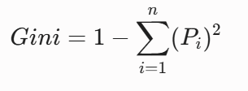
- Information Gain: Based on Entropy (the measure of chaotic impurity/randomness in data). It calculates the reduction in entropy achieved by partitioning data on a given attribute. It ranges from 0 to 1.
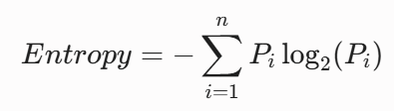

Merits and Demerits of Decision Trees

Merits:
- Interpretability: Highly transparent structure that mimics human flow-chart-like reasoning paths.
- No Feature Scaling Required: Works perfectly with raw continuous numerical values or categorical values without requiring standardization or normalization.
- Handles Non-Linear Relations: Captures non-linear feature behavior patterns effectively via recursive partitioning spaces.

Demerits:
- High Proneness to Overfitting: Without limiting hyperparameters like max_depth, trees can easily create overly complex structures that capture noise instead of clean patterns.
- Instability (High Variance): Minor changes or variations in the training sample structure can generate a completely different tree topology.
- Greedy Disadvantage: Making locally optimal decisions at every individual split stage does not guarantee reaching a globally optimal tree structure.

